BASIC
  - LGU Name - PORAC
  - LGU Type - Municipality
  - Province - Pampanga
  - Congressional District - Second
  - Income Class - First
  - List of Component Cities, Municipalities or Barangays

Name of Component City /Municipality / Barangay | Land Area (in has.)
1. Babo Pangulo | 510
2. Babo Sacan | 153
3. Balubad | 249
4. Calzadang Bayu | 434
5. Camias | Undetermined
6. Cangatba | 229
7. Diaz | Undetermined
8. Hacienda Dolores | 1308
9. Inararo | Undetermined
10. Jalung | 367
11. Mancatian | 636
12. Manibaug Libutad | 883
13. Manibaug Paralaya | 397
14. Manibaug Pasig | 1,021
15. Manuali | 1,418
16. Mitla Proper | 413
17. Palat | 385
18. Pias | 305
19. Pio | 1,653
20. Planas | 1,937
21. Poblacion | 128
22. Pulong Santol | 479
23. Salu | 350
24. San Jose Mitla | 240
25. Sapang Uwak | Undetermined
26. Sepung Bulaon | 277
27. Siñura | 317
28. Sta. Cruz | 364
29. Villa Maria | Undetermined

  - Land Area (in km2) - 34, 310 hec.

  - Brief History / Legal Bases of Creation

The name ͞Porac͟ is derived from the word ͞purac͟ after the abundant Purac tress encountered by the first settlers and is believed to be the first town established in Pampanga. The then Provincial Surveyor Don Ramon N. Orozco in 1879 called the river in this place ͞Poraq River͟ in his sketch of the nearby town of Floridablanca. Puraq later became what is now known as Porac on September 16, 1867.

Agriculture came to the place with the settling of Pampangans, native of Malayan extraction, accompanied by a small number of Spaniards. Porac was a ranch in the slope of the mountain known as Batiawan. Due to the scarcity of water in the mountains the residents moved to the lower grounds near
͞Poraq River͟ to sustain their water needs.

In 1853, the settlements in Porac were composed of six barangays namely Dolores, Manibaug, Mitla, Pias y Pio, Pulung Santol and Salu with a total population of 5,408. By early nineteenth century, Porac was a stable agricultural town with its own church, local government, and a Guardia Civil detachment to protect the community from attacks by the Balugas. Spaniards from the Guardia Civil intermarried with the natives, giving the place a notable Spanish mestizo population (Andrade).

After the 1991 Mt. Pinatubo eruption, six (6) lowland and three (3) upland barangays namely Camias, Cangatba, Diaz, Inararo, Mancatian, Manibaug Pasig, San Jose Mitla, Mitla Proper and Poblacion were either partially or completely buried under lahar. This forced residents to evacuate to different temporary relocation sites in neighboring provinces of Tarlac and Nueva Ecija. In 1992, the National Government, through the Mt. Pinatubo Commission and the Municipal Government started building several relocation sites within the municipality. In 1995, the Pio Model Community was finished and housed displaced residents from Cangatba, Mancatian, Manibaug Pasig, Mitla Proper, Poblacion and San Jose Mitla. This was followed by the relocation of the Aetas from Barangay Inararo to the Planas Tent City in 1997.

Today, with the construction of the Subic-Clark-Tarlac Expressway (SCTEX), Porac is seen as becoming the Industrial Hub of Central Luzon with investments coming from companies like the Ayala Land Inc. and the LLL Holdings because of its proximity to Clark International Airport and the Subic Bay Seaport.

    - LGU MAP

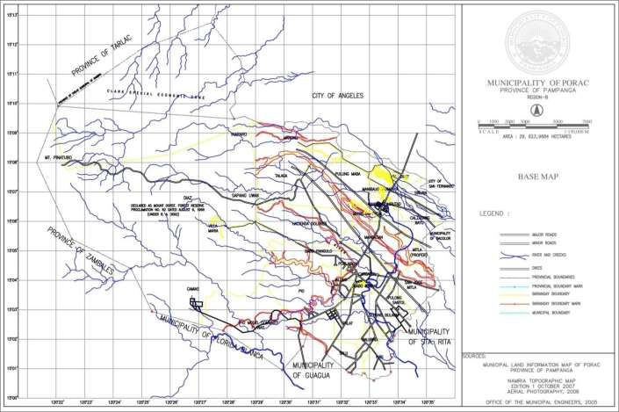
- LGU LOGO & SEAL

- LGU Vision and Mission OUR VISION
A developing economic and industrial hub with balanced ecology; empowered community, governed by responsive and dynamic leaders.

OUR MISSION

To establish sustainable development programs that will enhance greater economic and industrial activities while conserving the municipality’s natural resources in partnership with the community.

- Contact Information

Telephone Numbers | 045-329-2053
Fax Numbers | 045-329-2053
Official LGU Website | www.poracpampanga.gov.ph
Official E-mail Address | municipalityofporac@gmail.com

FINANCIAL

  - LOCAL AND EXTERNAL INCOME (2012)

IRA Share : Php 127,421,426
Locally Sourced Revenues : Php 64, 197, 274
Other Revenues : Php 4, 671, 440
Total LGU Income : Php 196, 290, 140

  - SUMMARY OF ANNUAL BUDGET

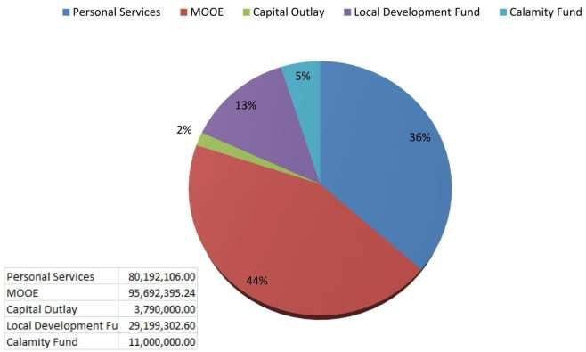

GEOGRAHIC /DEMOGRAPHIC 2012
  - POPULATION – (Source: NSO Census Year 2010)

Male - | No data
Female – | No data
Total Population – | 111,441

  - POPULATION GROWTH RATE (%) - N/A
  - DENSITY (Population per KM2) - N/A
  - NO. OF HOUSEHOLDS - 26, 164
  - NO. OF FAMILIES - 24, 662
  - NO. OF REGISTERED VOTERS - 55, 323
  - NO. OF CLUSTERED PRECINTS - 388

H.
LAND USE – in hectares and in % (data from LGU’s Planning and Development Office)

Land Use Category | 1999 |  | 2005 |  | 2010
 | Area(Ha) | % | Area(Ha) | % | Area(Ha) | %
Built-Up Areas | 1,162.25 | 3.38 | 1,700.00 | 4.95 | 3,020.00 | 8.8
Residential | 813.58 | 1,190.00 | 1,190.00 |  | 2,020.00 | 5.89
Commercial | 174.34 |  | 255 |  | 690 | 2.01
Institutional | 116.23 |  | 170 |  | 220 | 0.64
Parks & Recreation | 58.1 |  | 85 |  | 90 | 0.26
Agricultural | 7,582.00 | 22.89 | 7,552.00 | 22 | 9,493.00 | 27,67
Industrial | 514.25 | 1.5 | 918.25 | 2.7 | 720.25 | 2.1
Mining Area | 2,109.90 | 6.15 | 1,980.00 | 5.77 | 5,465.75 | 15.93
Lahar Area | 7,059.85 | 20.58 | 6,548.00 | 19.08
Forestlands | 15,611.75 | 45.5 | 15,611.75 | 45.5 | 15,611.75 | 45.5
Production | 11,969.55 |  | 11,969.55 |  | 11,969.00 | 76.67
Protection | 3,641.70 |  | 3,641.70 |  | 3,641.70 | 23.33
TOTAL | 34,310.00 | 100 | 34,310.00 | 100 | 34,310.00 | 100

I. RELIGION (in percentage)

RELIGION |  |  |  |  |  | %
Christianity |  |  |  |  |  | No data
 | -Roman Catholics
 | -Protestants
 | - Iglesia Ni Kristo
 | - Other Christian religions
Islam |  |  |  |  |  | No data
Others |  |  |  |  |  | No data

J. MAJOR SPOKEN DIALECT : Kapampangan & Filipino

K.
List of Indigenous People or Indigenous Cultural Communities (Source: NCIP only)

 | NAME OF TRIBE | TOTAL NUMBER | NAME OF BARANGAY | REMARKS
 |  | OF ICCS/IPS | WHERE THEY ARE
 |  |  | LOCATED
Aeta |  | 1,973 | Camias | n/a

 |  | 876  779  352 |  |  |  | Villa Maria
 |  |  |  |  |  | Inararo
 |  |  |  |  |  | Diaz
 |  | 1,077 |  |  |  | Sapang Uwak

ADMINISTRATIVE
  - INCUMBENT OFFICIALS

(For Province: Governor, Vice-Governor, Mayor and Vice Mayor)
(For HUC/CC/Mun.: Mayor, Vice-Mayor and Punong Barangays)

 |  |  |  |  |  |  |  |  |  | Highest Educational Attainment | Remarks (write any other remarkable or important info  here)
Name |  | Position |  | Gender |  | Term of Office |  | Political Party Affiliation
Condralito B. Dela Cruz |  | Mayor |  | Male |  | 2nd |  | NPC, Kambilan |  | College | n/a
Dexter Alber David |  | Mayor |  | Male |  | 2nd |  | NPC, Kambilan |  | College | n/a

  - PRESENCE OF MANDATORY COUNCILS / COMMITTEES

MANDATORY COUNCIL | EXECUTIVE ORDER  No. | DATE CREATED | Schedule of Regular Meeting
Local Development Council | EO-003-A-2010 | August 9, 2010
Local Health Board | EO-004-A-2010 | August 9, 2010
Local Housing Board | n/a | n/a
Local School Board | EO-005-A-2010 | August 9, 2010
Local Peace and Order | EO-006-A-2010 | August 9, 2010
DRRMB | EO-022-S-2011 | October 6, 2011
SWMB | EO-008-A-2010 | August 3, 2011
PLEB | EO-007-A-2010 | August 9, 2010
BAC | EO-021-2011 | August 19, 2011

  - LIST OF ACCREDITED NGOS, POS, AND SIMILAR AGGRUPATIONS
(see DILG MC No. 2010-73)

Name Of Organization | Head of the Organization | Objective or Purpose of Services Offered | Date of Accreditation | Accredited by | Contact Nos.

1. TAU GAMMA PHI | n/a | Community | September 13, | Municipal | n/a
& TAU GAMMA |  | Projects | 2011 | Ordinance
SIGMA
2. COBRA | n/a | Community | October 22, | Municipal | n/a
COMMUNITY |  | Support | 2008 | Ordinance
SUPPORT GROUP
3. JUSTICE LEAGUE | n/a | Community | June 24, 2008 | Municipal | n/a
COMMUNITY TASK |  | Support |  | Ordinance
GROUP
4. PORAC RACING | n/a | Preservation & | May 6, 2008 | Municipal | n/a
PIGEON CLUB |  | Protection of |  | Ordinance
 |  | Animals

SOCIAL
  - EDUCATION
  - No. of Public and Private Schools

School | PUBLIC |  |  | PRIVATE
 | No. of Schools | No. of Teachers | No. of Classrooms | No. of Schools | No. of Teachers | No. of Classrooms
Pre-School (inc. daycare) | 30  Daycare 16  PreElem | 46 | 46 | No data | No data | No data
Elementary | 26 | 336 | 317 | 7 | No data | No data
Highschool | 6 | No data | No data | 3 | No data | No data
College | 1 | 10 | 8 | No data | No data | No data
Vocational | 1 | No data | No data | No data | No data | No data
Graduate | 0 | 0 | 0 | 0 | 0 | 0

  - NET ENROLLMENT RATIO OR RATE OF PARTICIPATION (ELEMENTARY, SECONDARY) NO DATA AVAILABLE
-participation rate is the ratio between enrollment in the school age range to the total population of that age range . The official school age is 6-11 for elementary and 12-15 for secondary)

  - LITERACY RATE - NO DATA AVAILABLE
  - STUDENT-TEACHER RATIO -NO DATA AVAILABLE
  - STUDENT-CLASSROOM RATIO - NO DATA AVAILABLE

  - HEALTH

  - NO. OF HEALTH WORKERS:

HEALTH WORKERS | PERMANENT | CASUAL | JOB ORDER | OTHERS (EX. VOLUNTEERS)
DOCTORS | 3 | 0 | 0 | 0
NURSES | 2 | 3 | 1 | 0
MIDWIVES | 21 | 7 | 1 | 0
DENTISTS | 2 | 0 | 0 | 0
BHWS | 0 | 0 | 0 | 204

  - NO. OF HOSPITALS

 | PUBLIC |  | PRIVATE
LEVEL OF HOSPITALS | NO. OF HOSPITALS | TOTAL NO. OF BED CAPACITY | NO. OF HOSPITALS | TOTAL NO. OF BED CAPACITY
LEVEL I | 1 | 75 | 0 | 0
LEVEL II | 0 | 0 | 0 | 0
LEVEL III | 0 | 0 | 0 | 0
LEVEL IV | 0 | 0 | 0 | 0

  - NO. OF RURAL HEALTH UNITS (RHUs) - 2

  - NO. OF BGY. NUTRITION SCHOLARS (BNS) - 33
  - HEALTH WORKER-POPULATION RATIO

 | RATIO
DOCTOR-POPULATION | 1: 37,147
NURSE – POPULATION | 1: 18,574
MIDWIFE – POPULATION | 1: 3,843
DENTIST-POPULATION | 1: 55,721
BHW-POPULATION | 1: 546

  - MORBIDITY RATE

TOP 5 LEADING CAUSE OF DEATH | MORBIDITY RATE | REMARKS
CardioVascular Disease | Acute Respiratory Infection | n/a
Cancer | Skin Problem | n/a

Renal Failure | Injuries | n/a
Diabetes Mellitus | Masculoskeletal Disease | n/a
Pneumonia | Hypertension | n/a

    - 7 MORTALITY RATE
      - INFANT: 0.02%
• CHILD: 0.05%
      - MATERNAL : 0%

  - PEACE AND ORDER
c.1 IA/CPSP TITLE AND DATE OF APPROVAL (latest)
    - 2 VAWC DESK OFFICERS

POLICE STATION (including sub-police stations) | NAME OF PNP WOMEN’S DESK | HOTLINE NUMBERS
Poblacion (Headquarters) | PO1 Ronan Dizon | 166
Pio | PO1 Hazel Daludong | 166
Manibaug Libutad | PO1 Elerica Mallari | 166

  - NO. OF FORCE MULTIPLIERS

NAME OF BARANGAYS | TOTAL NO. OF TANODS APPOINTED | TOTAL NO. OF TANODS TRAINED | VAW Desk Person
Babo Pangulo | 18 | 18 | Janet L. Serrano
Babo Sacan | 15 | 15 | Bernardita G. Serrano
Balubad Calzadang Bayu | 15 | 15 | Ma. Perla G. Tayag
 | 22 | 22 | Angelita Manalo
Camias | 20 | 20 | Gemma S. Danan
Cangatba | 12 | 12 | Rowena Tumangi
Diaz | 10 | 10 | Mylene Baluyot
Hacienda Dolores | 21 | 21 | Perla Casas
Inararo | 14 | 14 | Mary Yugyug
Jalung | 11 | 11 | Amelia Duya
Mancatian | 20 | 20 | Mylene A. Juachon
Manibaug Libutad | 12 | 12 | Erlinda Mendoza
Manibaug | 20 | 20 | Remedios Villadelrey

Paralaya
Manibaug Pasig | 22 | 22 | Nimfa L. Calatong
Manuali | 19 | 19 | Luisa C. Ramos
Mitla Proper | 0 | 0 | Marlyn Laxamana
Palat | 20 | 20 | Cecilia Buan
Pias | 20 | 20 | Josaline Layug
Pio | 25 | 25 | Cheennee S. Ocampo
Planas | 20 | 20 | Remy M. Soliman
Poblacion | 19 | 19 | Socorro M. David
Pulung Santol | 18 | 18 | Aurora S. Garcia
Salu | 16 | 16 | Ligaya T. Sula
San Jose Mitla | 13 | 13 | Mary Jane Sape
Sapang Uwak | 10 | 10 | Filipinas P. Buco
Sepung Bulaon | 15 | 15 | Rita Lasdac
Siñura | 14 | 14 | Nelia S. Lusung
Sta. Cruz | 20 | 20 | Marjorie R. Manaloto
Villa Maria | 12 | 12 | Marife Camaya

  - PNP, BFP AND BJMP PERSONNEL –POPULATION RATIO

 | No. of PERSONNEL | PERSONNEL-POPULATION RATIO
PNP | 40 | 1: 2,800
BFP | 11 | 1: 10,131
BJMP | 0 | 0

  - CRIME VOLUME FOR YEAR 2012

 | TOTAL
INDEX CRIMES | 58
NON-INDEX CRIMES | 62

  - NO. OF JAILS IN THE LOCALITY AS OF June 2013 : 1

TYPE OF JAIL
(Provincial jail, district jail, detention
LOCATION/ADDRESS

cell (LGU)
Detention Cell | Municipal Hall

  - SHELTER FOR ͞CHILDREN IN CONFLICT WITH THE LAWS͟ AND FOR ABUSED WOMEN AND CHILDREN

CATEGORY | SHELTER NAME | ADDRESS | CONTACT PERSON
CICL | 1. Porac Drop In center | Municipal Hall | Joanne M. Arcega, RSW  045 329 2053
For abused women and children | n/a | n/a | n/a

  - HOUSING

  - No. of Informal Settler Families (ISFs)

NO. OF ISFs | LOCATION
No data | No Data

  - Resettlement Sites in the LGU (existing and/or identified sites)

RESETTLEMENT SITE (SPECIFIC LOCATION) | LAND AREA | NO. OF FAMILIES OR BENEFICIARIES | LGU ASSISTANCE  (ex. Housing Project, livelihood assistance, etc.)
Porac Model Community | No data | No data | No data

  - DISASTER RISK REDUCTION MANAGEMENT (DRRM)
  - EXISTENCE OF DRRM OFFICE (EO or Ordinance)

Executive Order No. EO-022-S-2011  Municipal Ordinance No.  MO No. 11-2005 | Organization of the Municipal Disaster Risk Reduction Management Council of Porac  Ordinance Enacting the Municipal Solid Waste Management of Porac | October 6, 2011  November 21, 2005

  - Name of Designated or Appointed DRRM Officer: Mr. Jim P. Garcia
  - DRRM Fund : Php 11,000,000.00 for year 2013
  - Rescue Teams (LGU Rescue Team and other volunteer groups)

Name of Rescue Team/s | Hotline Numbers | Team Leader/Head | No. Of Manpower
Brgy. Pasig Rescue Team | 045 329 3223 | Ponciano Loanzon | 20
Brgy. Cangatba Rescue Team | 045 329 3223 | Mario Gapasin | 10
Brgy. Planas Rescue Team | 045 329 3223 | c/o Mr. Jim Garcia | 8
Brgy. Jalung Rescue Team | 045 329 3223 | Nilo Tayag | 14
Brgy. Pio Rescue Team | 045 329 3223 | Reymar Garong | 11

  - LGU Disaster Response Capability PayLoader
Dump Truck Bulldozer Grader Chain Saw Axe & Rope
  - Early Warning System Ambulances Mega Phone Church Bells
  - List of Evacuation Centers

Evacuation Center(s) | Location | Capacity  (no. of individual it can accommodate) | Facilities and Utilities Available  (potable water, comfort rooms, etc)
Sta. Cruz  Elementary School | Brgy. Sta. Cruz, Porac | 400 individuals | water, electricity & Comfort Rooms
Pio Elementary School | Model Community, Pio, Porac | 500 individuals | water, electricity & Comfort Rooms

  - NO. OF POPULATION AT RISK

BARANGAY | TOTAL NO. OF FAMILIES AT RISK
 | Senior Citizen | Infant & Children (age 0-17) | PWDs | Total
Manibaug Pasig | n/a | n/a | n/a | 200 Families

  - VULNERABLE AREAS/ HAZARD MAPS

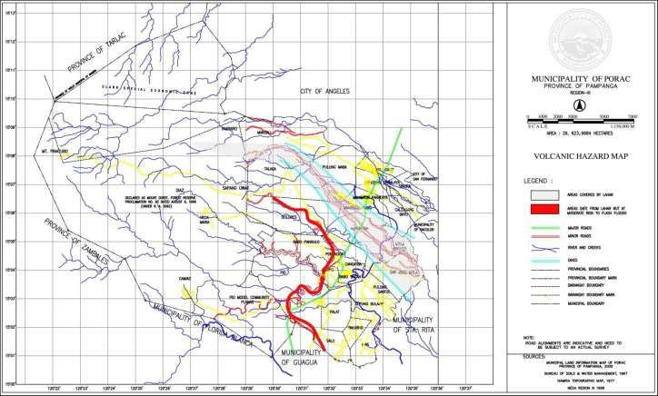

ECONOMIC

  - MAJOR INDUSTRIES (Top 5 only)
    - Farming
    - Resorts Operation
    - Halllow Blocks
    - Food Processing
    - Baking and Pastries

  - MAJOR SOURCES OF LIVELIHOOD (Top 5 only)
    - Farming
    - Construction Works/Carpentry
    - Employment with different industries

  - EMPLOYMENT RATE – n/a

  - MAJOR ESTABLISHMENTS (Top 5 only, ex. malls, resorts, etc.)
    - Resorts
    - Vibro sand quarry
    - Hardware & Construction Supply 4.
  - TOURISM
  - Tourist Spots and Historical Sites (TOP 5 ONLY) attach photo of the site)

TOURIST SPOTS/SITES | LOCATION | PICTURE
Tourist Spots  - Miyamit Falls  - Porac Viewing Decks  - Porac Upland Communities  - Poracay Resort  - Porac River | Porac Upland Porac Upland Porac Upland Manibaug Pasig Porac | 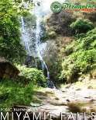

 |  | 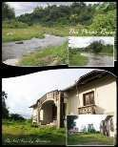
Historical Sites  - St. Catherine of Alexandria Parish  - Pio Chapel  - Hacienda Dolores Chapel  - Gil Family Mansion  - Century Old Acacia Tree | Brgy. Poblacion Brgy. Pio  Brgy. H. Dolores Brgy. Pio  Brgy. H. Dolores | 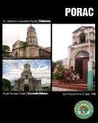

  - Facilities

TOURISM FACILITIES | TOTAL | NO. OF ROOMS  (for Hotel, Motel, Apartelle, transient home) | NO. OF SITTING CAPACITY (for  restaurant) | NO. OF PERSON IT CAN ACCOMMODATE  (for SPA)
HOTEL/MOTELS | 1 | 15 | n/a | n/a
APPARTELLE/TRANSIENT HOME | n/a | n/a | n/a | n/a
RESORTS | 20 | n/a | n/a | n/a
NO. OF RESTAURANT | 3 | n/a | 50 | n/a
NO. OF SPA | n/a | n/a | n/a | n/a

  - LIST OF LOCAL PRODUCTS AND SERVICES

PRODUCTS AND SERVICES | PHOTO OF THE PRODUCT/S with caption
PRODUCTS
- Processed Food
- Cassava Cake
- Uraro

  - LIST OF LOCAL FESTIVITIES (i.e. Foundation Day , Town Fiestas, and others)

Name of Festival/Local Event | Celebration/Observance Date
Balas Festival | 15-Jun
Binulo Festival | Every November
Porac Foundation Day | 31-Oct
Feast of St. Catherine (Patroness of the Town) | 25-Nov
Camias | 22-Jan
Calzadang Bayu | 24-Jan
San Jose Mitla | 19-Mar
Pias | 19-Mar
Planas | 19-Mar
Pulung Santol | 20-Apr
Mitla Proper | 25-Apr
Villa Maria | 2-May
Sta. Cruz | 3-May
Pio | 7-May
Model Community, Pio | 2nd Sunday of May
Balubad | 15-May
Babo Pangulo | 15-May
Manibaug Libutad | 31-Jul
Manibaug Paralaya | 31-Jul
Manibaug Pasig | July
Sepung Bulaon | 16-Aug
Mancatian | 10-Sep
Hacienda Dolores | 15-Sep
Palat | 10-Sep
Siñura | 3-Oct
Jalung | 4-Oct
Salu | 25-Nov
Babo Sacan | 4-Oct

Cangatba | 25-Nov
Poblacion | 25-Nov

  - BASIC UTILITIES

 | LOCAL TV STATION | LOCAL RADIO STATION | LOCAL PRINT MEDIA | TELECOMMUNICATION/ INTERNET PROVIDER | ELECTRICITY | WATER
NAME OF SERVICE PROVIDER | CLTV36 | GV FM RW FM | Headlines Sustar Punto | Smart, Globe, PLDT, Digitel  Comclark, Smartbro | PELCO | PORAC WATER DISTRICT  PORAC WATERWORKS
TOTAL | 1 | 2 | 3 | 7 | 1 | 2

  - MODES OF TRANSPORTATION : By Land (Jeep, Tricycle, Bike)

  - SOURCE OF WATER SYSTEM (can have multiple answers): Level I, II & III

Levels of water systems
Level I | Stand-alone water points, e.g., handpumps, shallow wells, rainwater collectors
Level II | Piped water with a communal water point, e.g., borewell, spring system
Level III | Piped water supply with a private water point, e.g., house connection

ENVIRONMENTAL

  - Types of Ecosystem (can have multiple answers)

Put  - or X | TYPE OF ECOSYSTEM
x | MARINE –presence of dive sites, mangroves, fish sanctuaries
x | FRESHWATER –presence of mangroves
 | FOREST – presence of reforestation areas, plant nurseries, etc.
Rural | URBAN/RURAL

  - SOLID WASTE MANAGEMENT

  - DISPOSAL FACILITIES

TYPE (open, controlled, sanitary landfill) | LOCATION/ ADDRESS | NO. OF MANPOWER | AVAILABLE EQUIPMENT/  MACHINES (list down)
n/a

  - MATERIAL RECOVERY FACILITIES

BARANGAY | LOCATION OF MRF | NO. OF MANPOWER | AVAILABLE EQUIPMENT/MACHINES
San Jose Mitla | San Jose Mitla | 16 | Compactor, Conveyor Pay Loader, DumpTruck
Balubad | Balubad | 2 | N/A

  - NO. OF GARBAGE TRUCKS (OWNED BY THE LGU): 4

  - EXISTANCE OF LOCAL ORDINANCE/S RELATIVE TO RA 9003 COMPLIANCE

Executive Order No. EO-022-S-2011  Municipal Ordinance No.  MO No. 11-2005 | Organization of the Municipal Disaster Risk Reduction Management Council of Porac  Ordinance Enacting the Municipal Solid Waste Management of Porac | October 6, 2011  November 21, 2005

OTHERS
  - LOCAL AWARDS RECEIVED - 1. TB LINC Project - Highest Case Detection Rate and Cure Rate
2. Most Outstanding Barangay HEalth Workers
  - NATIONAL AWARDS RECEIVED - SEAL OF GOOD HOUSEKEEPING
  - LGU BEST PRACTICES AND INNOVATIONS - N/A
  - LIST OF PROJECTS FUNDED AND MONITORED BY DILG

Local Government Support Fund (LGSF)

Project Title and Description: Concreting of Brgy. Road along Brgy. Sta. Cruz Project Location: Purok 3, Brgy. Sta. Cruz
Target Beneficiaries: Residents of Brgy. Sta. Cruz Project Duration: 30 Calendar Days
Total Project Cost: 991,142.10 DILG Fund: 1 million
LGU Counterpart (Fund), if any: n/a

Remarks (status of the project and other notable info): Finished

Performance Challenge Fund (PCF)

Project Title and Description: Concreting & Asphalt Overlay at Doña Adela Phase 1 Project Location: Sta. Cruz, Porac
Target Beneficiaries: Residents of Brgy. Sta. Cruz Project Duration: 30 Calendar Days
Total Project Cost: DILG Fund: 1 million
LGU Counterpart (Fund), if any: 1 million
Remarks(status of the project and other notable info) : Finished

  - LIST OF LGU PLANS (WRITE THE TITLE AND LATEST DATE OF EFFECTIVITY)
    - CLUP
Comprehensive Land Use Plan of the Municipality of Porac, Pampanga For Approval at Sangguniang Panlalawigan (Series 2012)
    - SWMP - None
    - CDP/ELA - Executive and Legislative Agenda (Series 2011)
    - GAD - None
    - HRD - None
    - CLIMATE CHANGE ADAPTATION PLAN -None
    - OTHERS (PLEASE SPECIFY)

  - LIST OF CODES (PLEASE ENUMERATE)

TITLE | DATE ENACTED
Revenue Code | 2002
Local Investment & Incentive Code | 2012
Market Code | 2002
Code for Children | 2011
Gender & Development Code | 2009
Zoning Ordinance | 2011

